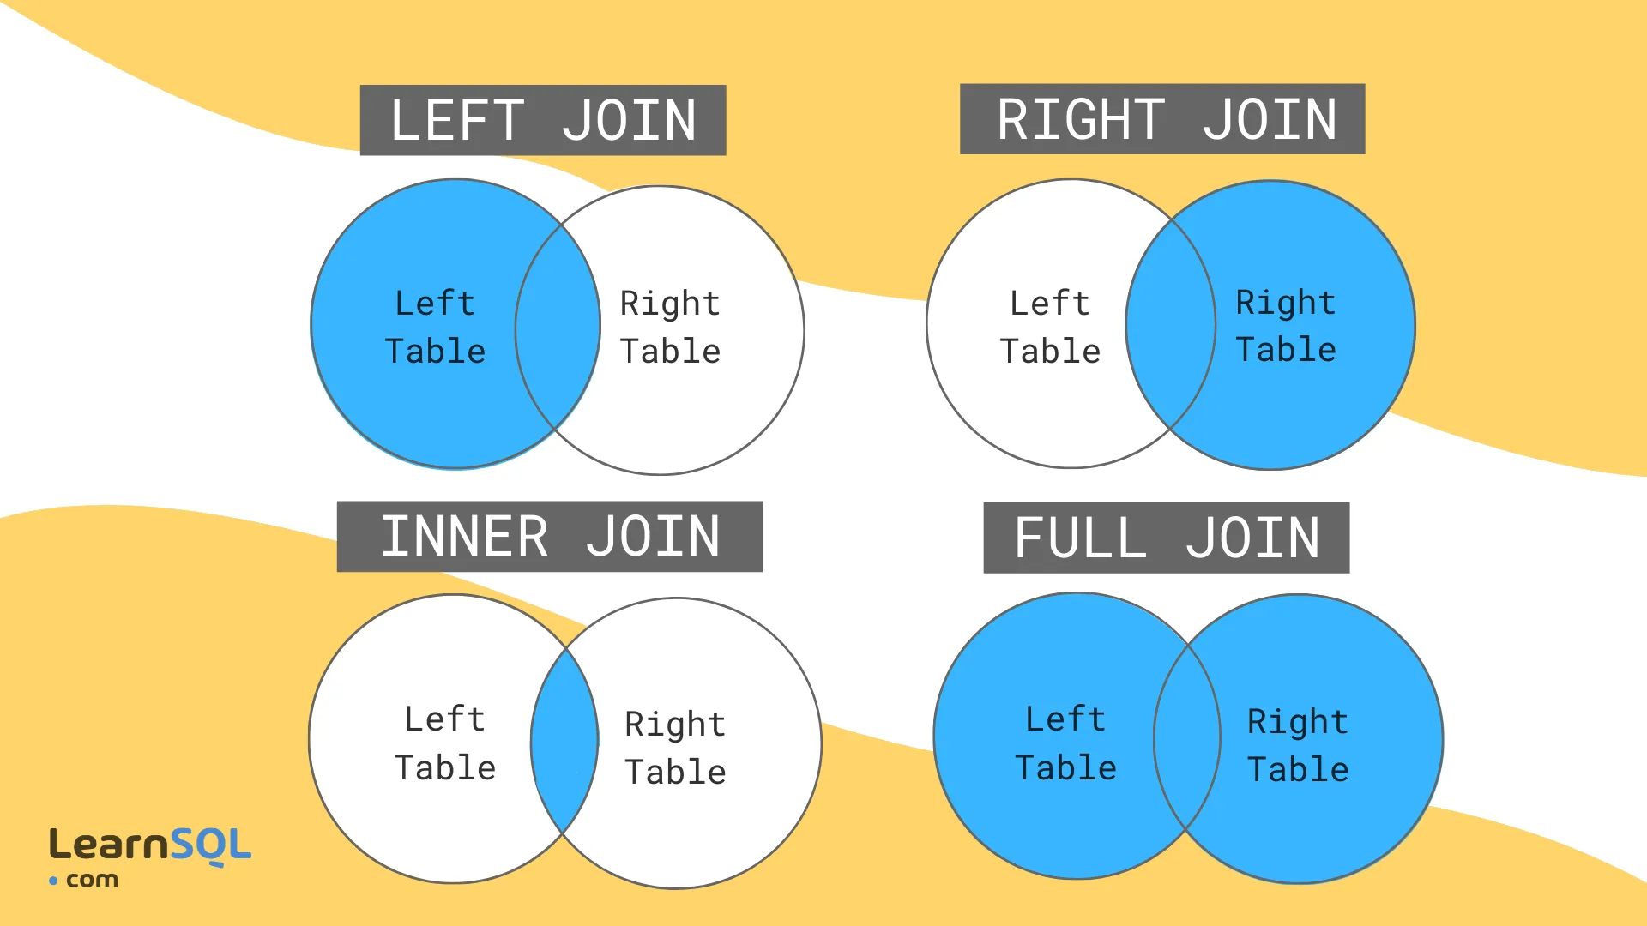

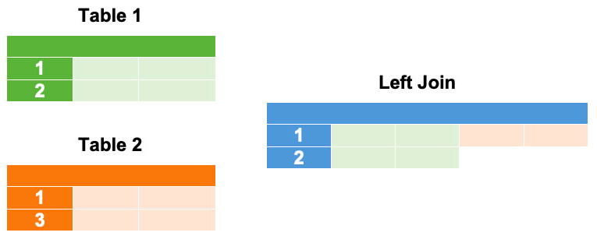
SELECT column names
FROM table1
LEFT JOIN table2
ON table1.common_column = table2.common_column;

Here are the customers and sales tables from our bookstore.
Customers
id | first_name | last_name | gender | age | customer_since
1 | Daniel | Black | M | 34 | 2014-10-13
2 | Erik | Brown | M | 25 | 2015-06-10
3 | Diana | Trump | F | 39 | 2015-10-25
4 | Anna | Yao | F | 19 | 2017-02-20
5 | Christian | Sanders | M | 42 | 2018-01-31
Sales
id | date | book_id | customer_id | quantity | amount
1 | 2019-09-02 | 2 | 3 | 1 | 14.99
2 | 2019-10-01 | 1 | 2 | 1 | 12.99
3 | 2019-10-01 | 3 | 4 | 1 | 15.75
To join these two tables and obtain the information we need for analysis, use the following SQL query:
SELECT c.id, c.first_name, c.last_name, c.gender, c.age, c.customer_since,
s.date AS sales_date, sum(s.amount) AS total_spent
FROM customers c
LEFT JOIN sales s
ON c.id = s.customer_id
GROUP BY c.id;

